Deep Fork Community Action Foundation, Inc.
223 W 6th Street
Okmulgee, OK 74447
918-756-2826

Serving residents of Okmulgee, Okfuskee, Hughes, & McIntosh Counties
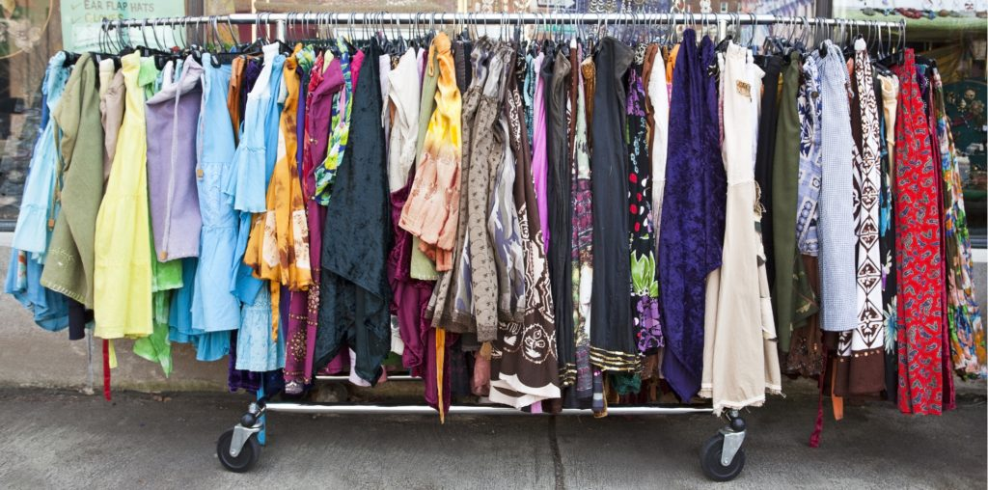

Food Pantry & Clothing Closet Assistance

When: Tuesdays & Thursdays

Hours: 9:00am – Noon & 1:00pm – 3:00pm

You must provide the following documents for the entire household……..

Photo Identification
Social Security Card
Proof of Residence
Attestation that household income does not exceed Federal Poverty Guidelines (FPL) for household size

