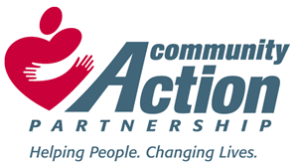
Deep Fork Community Action Foundation, Inc.
Prescription Assistance Services

223 West 6th Street – P.O. Box 670
Okmulgee, Oklahoma 74447
Office: 918-756-2826 – Cell: 918-759-1898
Facsimile: 918-756-6829 Email: Rxforok@dfcaf.org
www.Deepforkcommunityaction.org

Serving: Hughes, Okfuskee, Okmulgee, McIntosh, and Muskogee Counties

Thank you for your interest in the RX for Oklahoma Prescription Assistance Program! We look forward to helping you acquire your medications, however there are a few requirements that you should be aware of in order to process your assistance application.

- Complete the attached application in its entirety. Leaving questions blank may lengthen the application process.
- You MUST provide a copy of the following items for EVERYONE in your household:
- Valid Oklahoma Identification (State ID card, Drivers License)
- Social Security Card
- Proof of current income for (3) three months (Pay Stubs, Unemployment Compensation, Child Support, Alimony, Disability Determination Letter, Social Security Supplemental Income Letter, or any other income)
- Income taxes from the previous year
- Current Health/Prescription Insurance cards if any
- You MUST provide a CURRENT and ORIGINAL copy of each prescription, which includes (3) three refills. Please note that we may be able to assist you in obtaining these from your physician.

You may return the completed application to CRYSTAL PETREE either by mail, fax, or in person. If you have any questions or need assistance in completing the application, please don’t hesitate to contact us at the Deep Fork Community Action Offices.

